Phaleria macrocarpa Natural cream: Remedies for Obesity
¹Faqihah binti Zakir,¹ Khairunisa binti Shamshul Bahar, ^{2,3,4*}Siti Efliza Ashari, ⁴Nurul Qistina Mohd Zaidi Alimi, ^{3,4}Sharifah Nurfadhlin Afifah Syed Azhar
¹Kolej PERMATA pintar Negara, Universiti Kebangsaan Malaysia (UKM), 43600 Bangi, Selangor Darul Ehsan.
²Chemistry Unit, Centre of Foundation Studies for Agricultural, Universiti Putra Malaysia (UPM), 43400 Serdang, Selangor Darul Ehsan.
³Process Bioengineering Laboratory, Putra Infoport UPM, Universiti Putra Malaysia (UPM), 43400 Serdang, Selangor Darul Ehsan.
⁴Department of Chemistry, Faculty of Science, Universiti Putra Malaysia (UPM), 43400 Serdang, Selangor Darul Ehsan.

Phaleria macrocarpa (mahkota dewa) is a medicinal plant that originated from Yogyakarta, Indonesia. It is traditionally used by people for treating diseases such as hypertension, diabetes, cancer and kidney disorder. P. macrocarpa shows different bioactivities such as anti-oxidant, anti-inflammatory, anti-cancer, anti-hyperlipidemia and anti-bacterial. P. macrocarpa contains a high level of flavonoid and quercetin compound. Quercetin has the potential to reduce LDL cholesterol, raise HDL cholesterol and lowered blood pressure and blood sugar slightly. Therefore, the active ingredients contained in the fresh fruit of P. macrocarpa were used as its starting material in the formulation for the treatment of obesity.

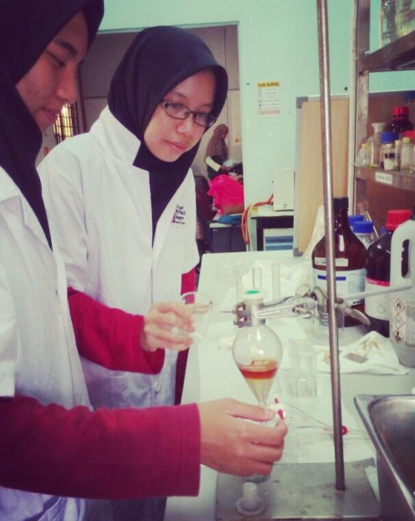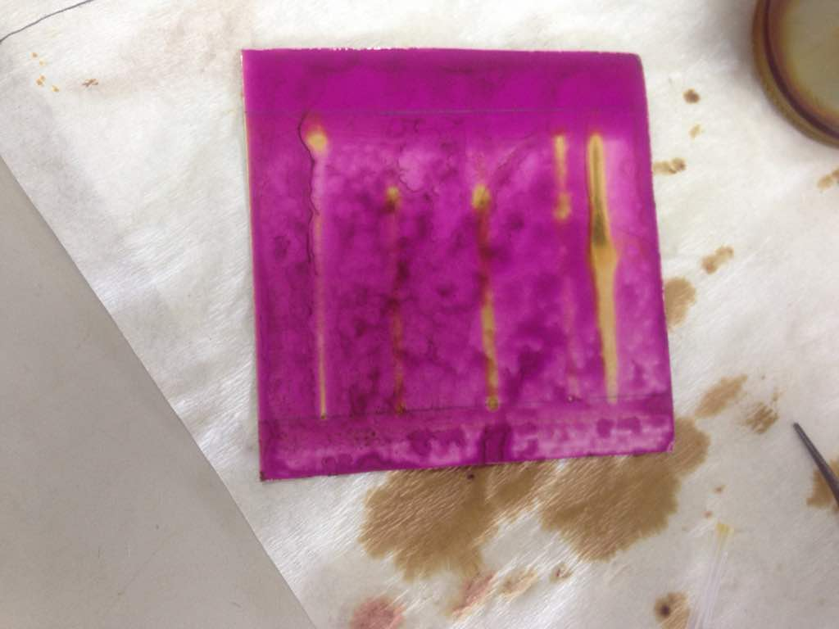
Day 1- Extraction process at Process Bioengineering Laboratory, Infoport, UPM
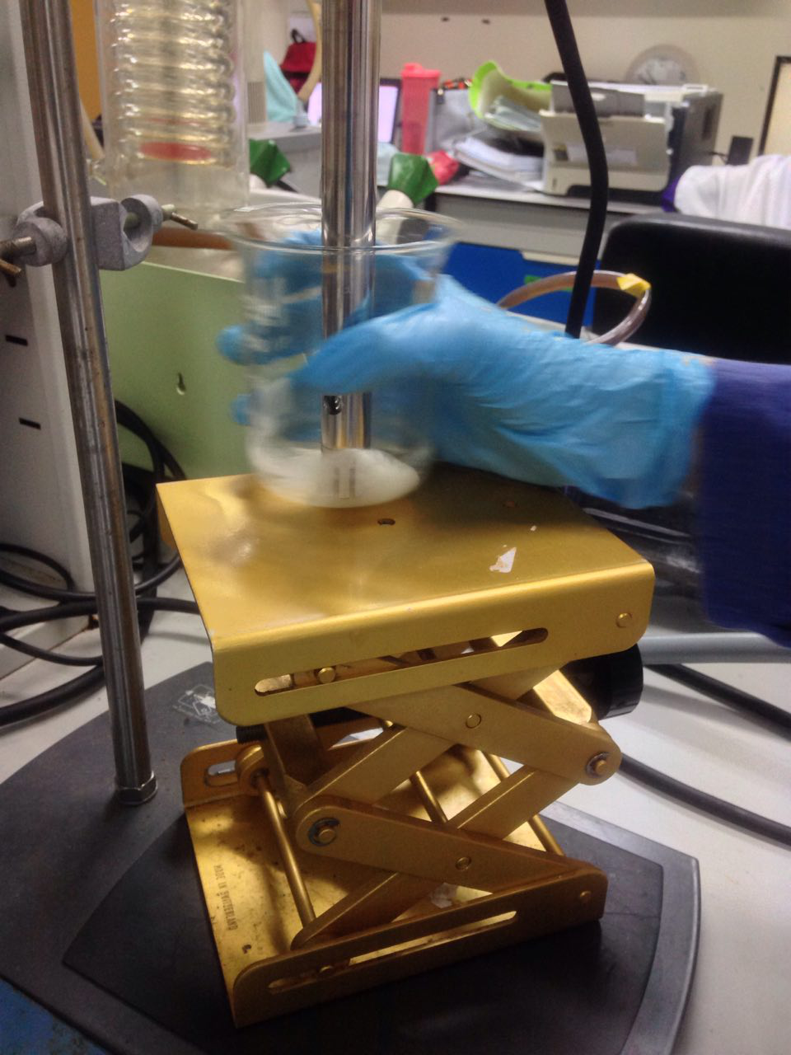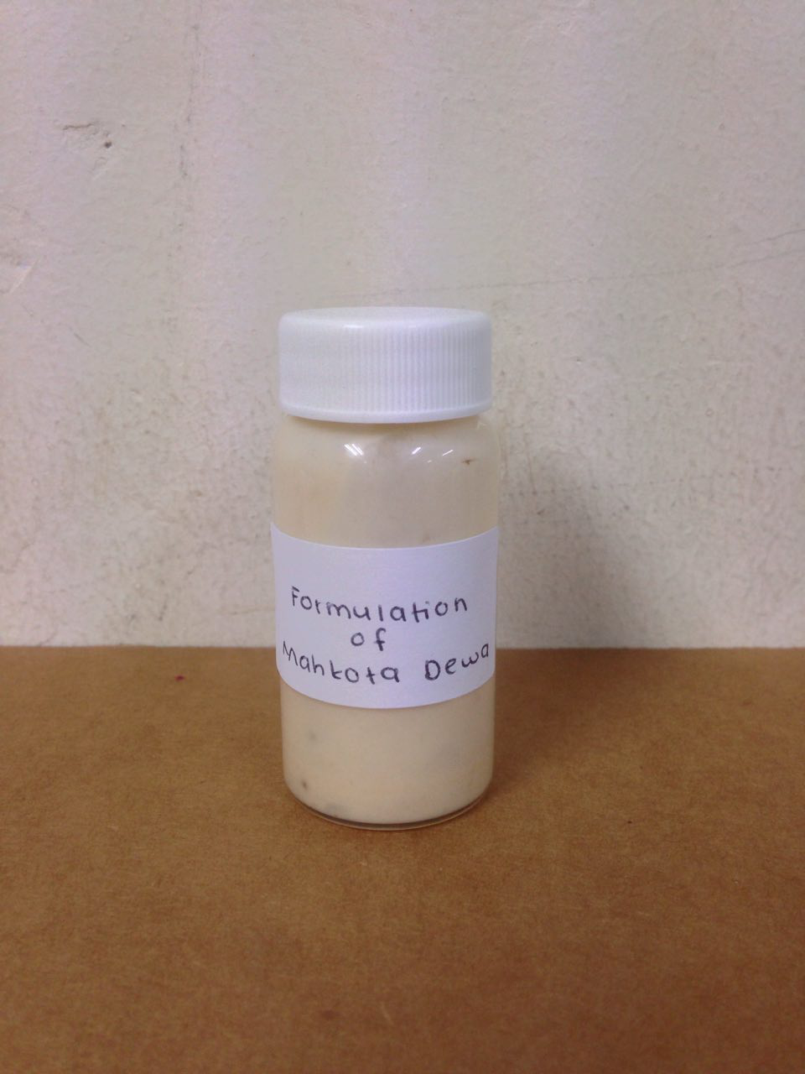
Preliminary formulation sample of P.macrocarpa

Our Booth at GISC 2017
Achievements:-
- Top 3 Award- The Most Outstanding Project (Science Cluster-Chemistry)
- Special Award- The Most Inventive Project
- Gold Medal
- The Best Facilitator Award

